Name: ______________________ Class: _____________ Reading level: ___________________
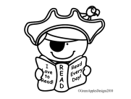Pirate Mystery Reading Challenge
AR challenge November 10-January 23
Students will read books on their level and for every 90% they will mark off a step along the path to the treasure!
Start
4
2
1

3

8
6
5

7

Treasure!

9
11
12
10
Reading Log
Reading level: ____________________________________________
Pirate steps are checked if you scored 90% or better.

Book Title | Author | Level | Score | Pirate step?

