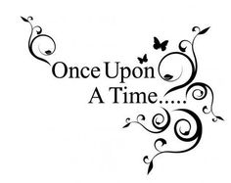Challenge: January 26 – March 20

we read a lot of books!

Read and pass **as many books** as you can in **7 weeks**. Students who **pass 10 books** on their **level** with an **80% or more** come to the reading celebration. Top 3 in each grade level receive a prize. Classes with the most in each grade level get a prize for the class and for the teacher. Color a fairy tale character for each 80% or better score.

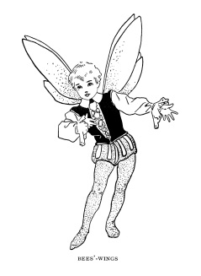  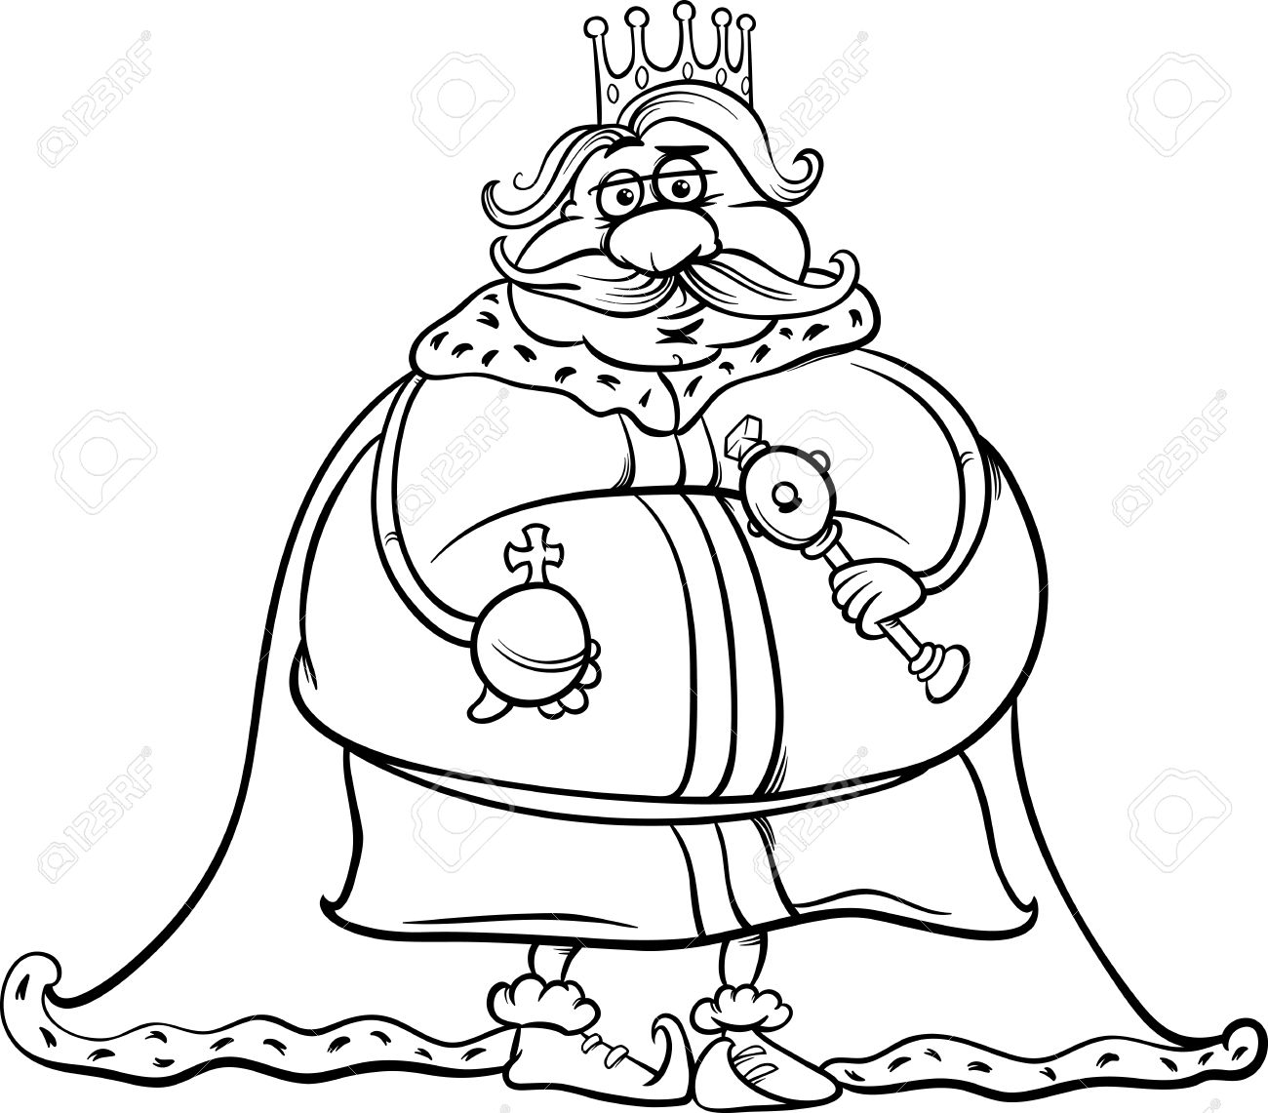 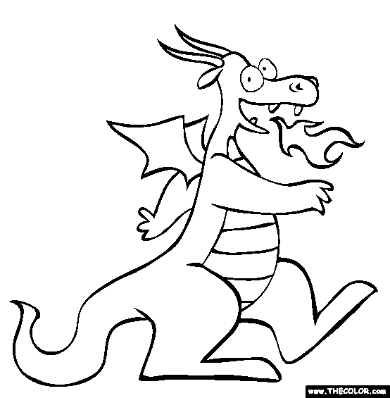 

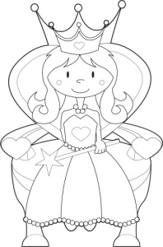 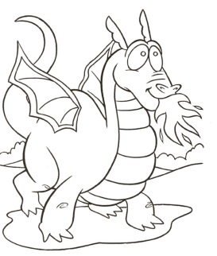  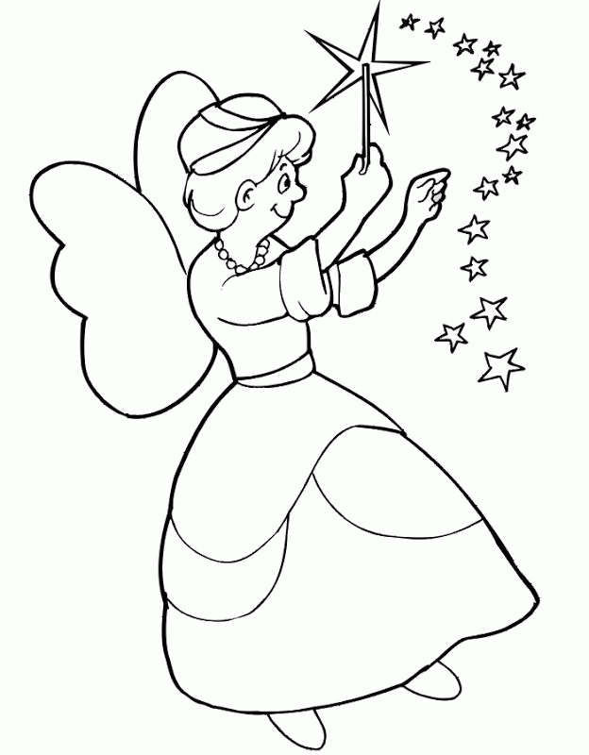 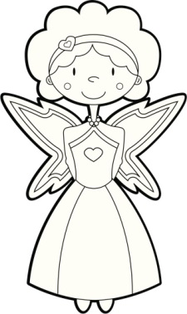

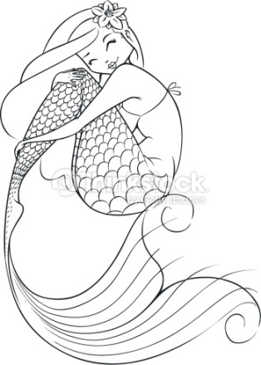  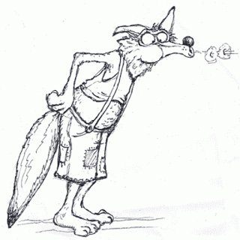 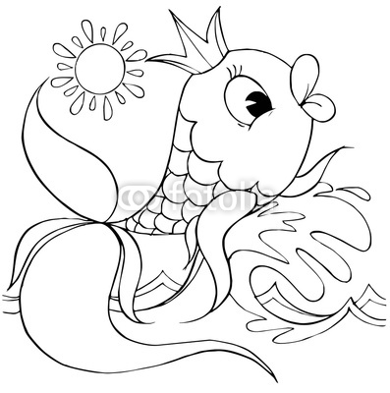

Name: ___________________________ Reading level: _______________________________

Fill in the chart with your test scores of 80% or better from January 26 to March 20.

|  |  |  |  |  |
| --- | --- | --- | --- | --- |
| Title | Author | Level | Score | Color? |
|  |  |  |  |  |
|  |  |  |  |  |
|  |  |  |  |  |
|  |  |  |  |  |
|  |  |  |  |  |
|  |  |  |  |  |
|  |  |  |  |  |
|  |  |  |  |  |
|  |  |  |  |  |
|  |  |  |  |  |
|  |  |  |  |  |
|  |  |  |  |  |
|  |  |  |  |  |
|  |  |  |  |  |
|  |  |  |  |  |
|  |  |  |  |  |
|  |  |  |  |  |